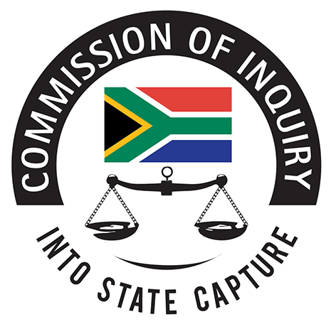
2nd floor, Hillside House
17 Empire Road,
Parktown
Johannesburg
2193
Tel (Internatiashe Deonal): +27 (10) 214-0651
Tel (Tollfree): 0800 222 097
Email: inquiries@sastatecapture.org.za
Web: www.sastatecapture.org.za

JUDICIAL COMMISSION OF INQUIRY INTO ALLEGATIONS OF STATE CAPTURE,
CORRUPTION AND FRAUD IN THE PUBLIC SECTOR INCLUDING ORGANS OF STATE

MEMORANDUM
15 November 2020

To: Deputy Chief Justice, Raymond Mnyamezeli Mlungisi Zondo
Chairperson: Judicial Commission of Inquiry into Allegations of State Capture, Corruption and Fraud in the Public Sector including Organs of State

Dear DCJ
RE: APPLICATION FOR LEAVE TO ADDUCE EVIDENCE AND CROSS EXAMINE
SEQ 06/2019

- SEQ 06/2020 granted on 03 December 2019 (order attached);
- Matter set down for 23 July 2020
- Postponed (see medical certificate).
- Current Status (15 November 2020): Postponed for further hearing.

Yours faithfully
LEGAL SERVICES & OPERATIONS
THE SECRETARIAT

