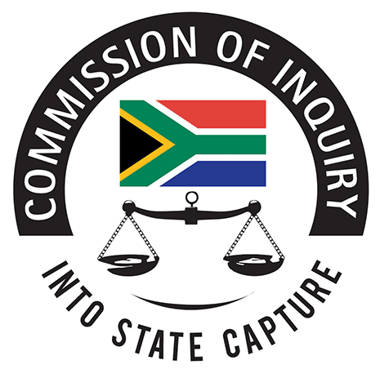
2nd floor, Hillside House
17 Empire Road,
Parktown
Johannesburg
2193
Tel (International): +27 (10) 214-0651
Tel (Tollfree): 0800 222 097
Email: inquiries@sastatecapture.org.za
Web: www.sastatecapture.org.za

JUDICIAL COMMISSION OF INQUIRY INTO ALLEGATIONS OF STATE CAPTURE,
CORRUPTION AND FRAUD IN THE PUBLIC SECTOR INCLUDING ORGANS OF STATE

MEMORANDUM
15 November 2020

To: Deputy Chief Justice, Raymond Mnyamezeli Mlungisi Zondo
Chairperson: Judicial Commission of Inquiry into Allegations of State Capture, Corruption and Fraud in the Public Sector including Organs of State

Dear DCJ
RE: APPLICATION FOR LEAVE TO ADDUCE EVIDENCE AND CROSS-EXAMINE
SEQ 24/2019

- SEQ 24/2019 granted on 25 March 2020 (order attached).
- Matter set down for 27 July 2020.
- Counsel for McBride requested a postponement regarding his cross-examination (extract of transcript attached).
- Nhleko gave evidence on 27 July 2020 and other days within that week.
- Documents and evidence bundled as Exhibit Y8 (handed up by Counsel in public hearing).
- Current Status (15 November 2020): Postponed for further hearing.

Yours faithfully
LEGAL SERVICES & OPERATIONS
THE SECRETARIAT

