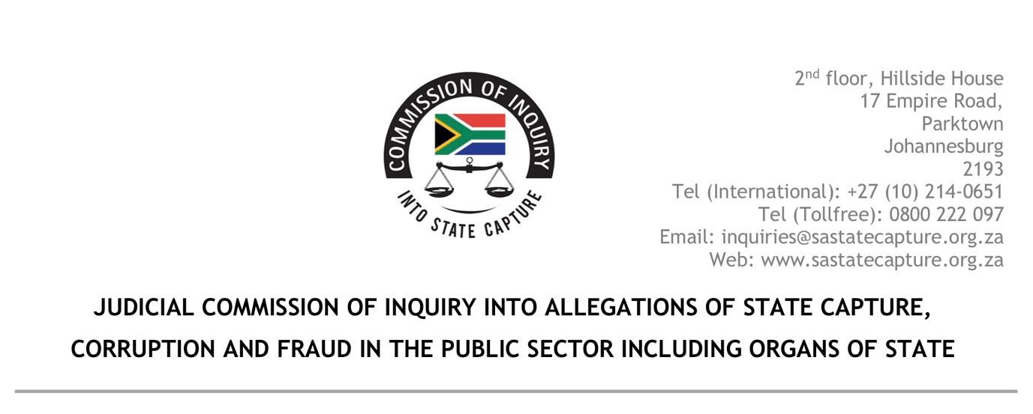
17 August 2020

ABSA GROUP LEGAL COUNSEL
ABSA

Dear Sir/ Madam

Re: SUMMONS FOR PRODUCTION: DETAILS ABSA ACCOUNT 10-4325-0805

On … you were served with summons for you to produce details regarding account number 10-4325-0805. A copy of the summons and an annexure thereto go herewith.

You have failed to comply with the summons and did not produce the requested information. As indicated in the summons such failure amounts to a criminal offence.

You are hereby requested to comply with the aforesaid summons on or before 21 August 2020. If you fail to comply with the summons as requested the Commission will have no option but lay criminal charges against you.

Yours truly

MS K B SHABALALA
Acting Secretary
Judicial Commission of Inquiry into Allegations of State Capture, Corruption and Fraud in the Public Sector including Organs of State

