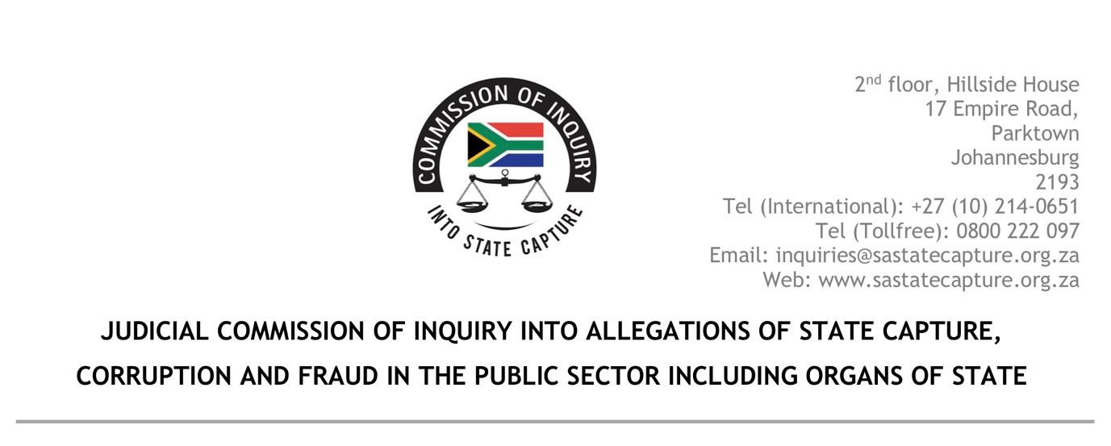
17 June 2020

Dear Adv. Skosana
Re: ADDITIONAL FUNDING REQUEST FOR THE FINANCIAL YEAR 2020/21: STATE CAPTURE COMMISSION
Our memorandum for additional funding dated the 3rd June 2020 is attached for your ease of reference.
Once again we would like to thank the department for the allocation of R150M for the current financial year. At our meeting at National Treasury on the 20th May 2020, the Acting Director-General made a firm undertaking that the Commission will be given sufficient resources to continue with its work. It is in the spirit of continuous engagement that you alluded to at the same meeting that we are approaching your office.
The investigative unit of the Commission depleted its allocation in the first week of June 2020. To prevent an unauthorised expenditure, the Commission was compelled to fund the Investigators from the budget allocation of the Legal Team for the remainder of the month of June.
It must be noted that unless we get an indication that new money will be allocated to the Commission by the 26th of June 2020, the Investigators will have no option but to cease work. This in turn will force us to wrap up and close the Commission.
We therefore request that the department funds the estimated shortfall of between R38 million and R42 million for the Investigative Unit of the Commission.

Yours faithfully

K.B Shabalala Acting Secretary: State Capture Commission

